Amazing ToDo app­­­­

project document

Grzegorz Witkowski

2022

Spis treści

Project description 2

Motivation and purpose 3

Lead time 3

Team members: 4

Definition of done: 4

Milestones 6

Technological stack 7

Visual mockups 8

# Project description

Amazing ToDo app is a .NET web application which allows users to create their own “ToDo” list. They can organize their day and establish an order of the tasks during the day.

It is the best way to improve you productivity and make more during the day. With this app you can limit time which you lose on planning the day during it. You can plan the day one day before, and just do your tasks according to the list, which have you made.

# Motivation and purpose

My main motivation was positive degree from Mgr. Filip Postępski from the subject of programming in .NET language.

Second motivation is to learn something new and see how .NET works and how is it like to be a .NET programmer.

# Lead time

Whole project took me about 6-8 hours. The most of time I spend on learning how .NET mechanics works.

Start time: 10.05.2022r.

End time: 18.05.2022r.

# Team members:

Grzegorz Witkowski – Project Leader, .NET Developer, UX designer, Database designer, Manual Tester.

# Definition of done:

Project is considered to be done, when all the design assumptions have been met.

That’s mean project has:

1. Main feature – ToDo list

ToDo list should contain:

1. Adding tasks
2. Removing tasks
3. Updating tasks
4. Getting tasks
5. Contact page which allows user to send message to the author of page
6. Privacy policy page
7. Layout

Layout should contain:

1. Header
2. Main part of website
3. Footer
4. Project documentation

# Milestones

1. Web app design

In this milestone the main task is to design the views of the page as user friendly as it is possible.

1. Initial config

In this milestone the main task is to set up the basic project in .NET, configure the Visual Code Studio to write C# code and install necessary software to use SQLite database.

1. MVP (Minimum viable product)

In this milestone I wanted to delivery the minimal project with only working ToDo list to make app usable.

1. Product Delivery

This is the last milestone. It assumes delivering fully consistent with the assumptions project.

# Technological stack

1. SQLite
2. .NET
3. Bootstrap

# Visual mockups

Home page:

Privacy Policy :

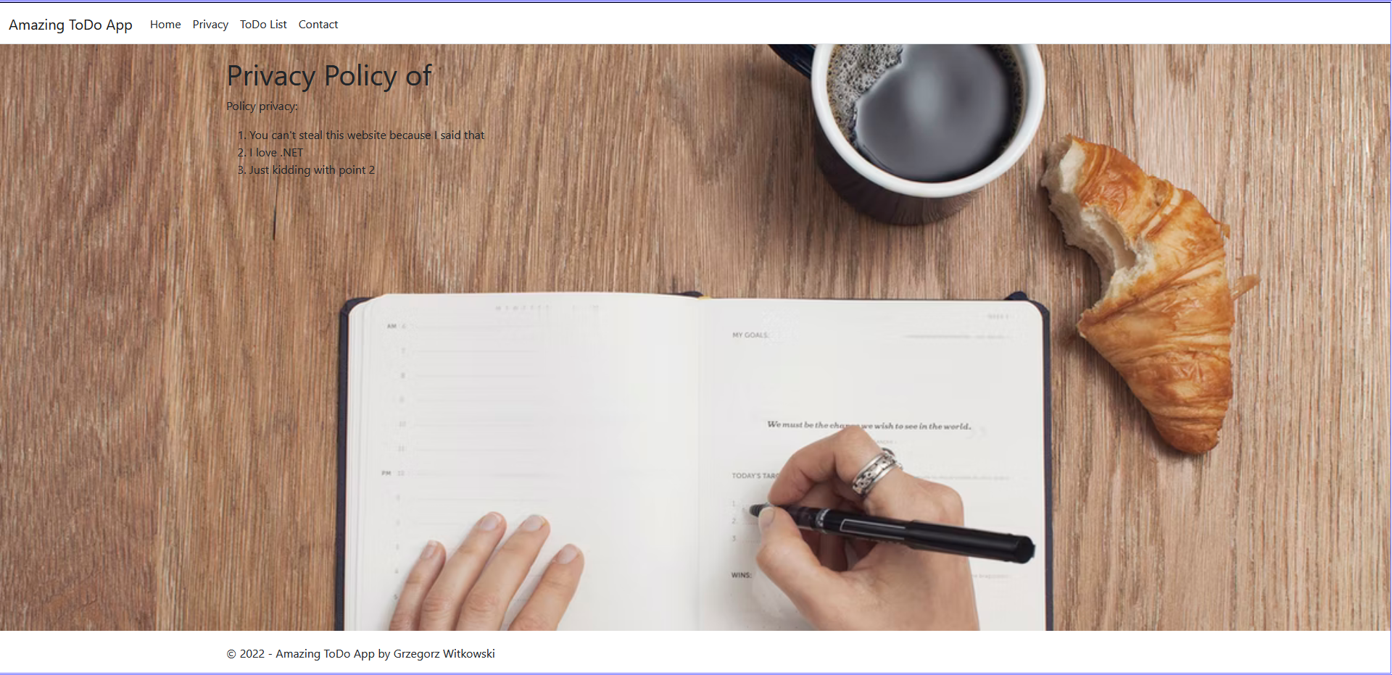

ToDo list:

Contact:

